Tasks

Task 1. What is the number of industrially developed countries of the world where total fertility rate in 2011 is in the range between 1.21 and 1.39? Which countries are they? Why the data from the World Population Data Sheet (http://www.prb.org/Publications/Datasheets/2011/2011-world-population-data-sheet.aspx), prepared by the Population Reference Bureau, are unsuitable for obtaining the answer? Is the database INED Population in figures (http://www.ined.fr/en/pop_figures/) fit for this?
Task 2. Crude marriage rate is one of the population indicators. Dynamics of it may be represented in graphic form. For example the last 63-year period for Germany, Holland, and Norway looks like:

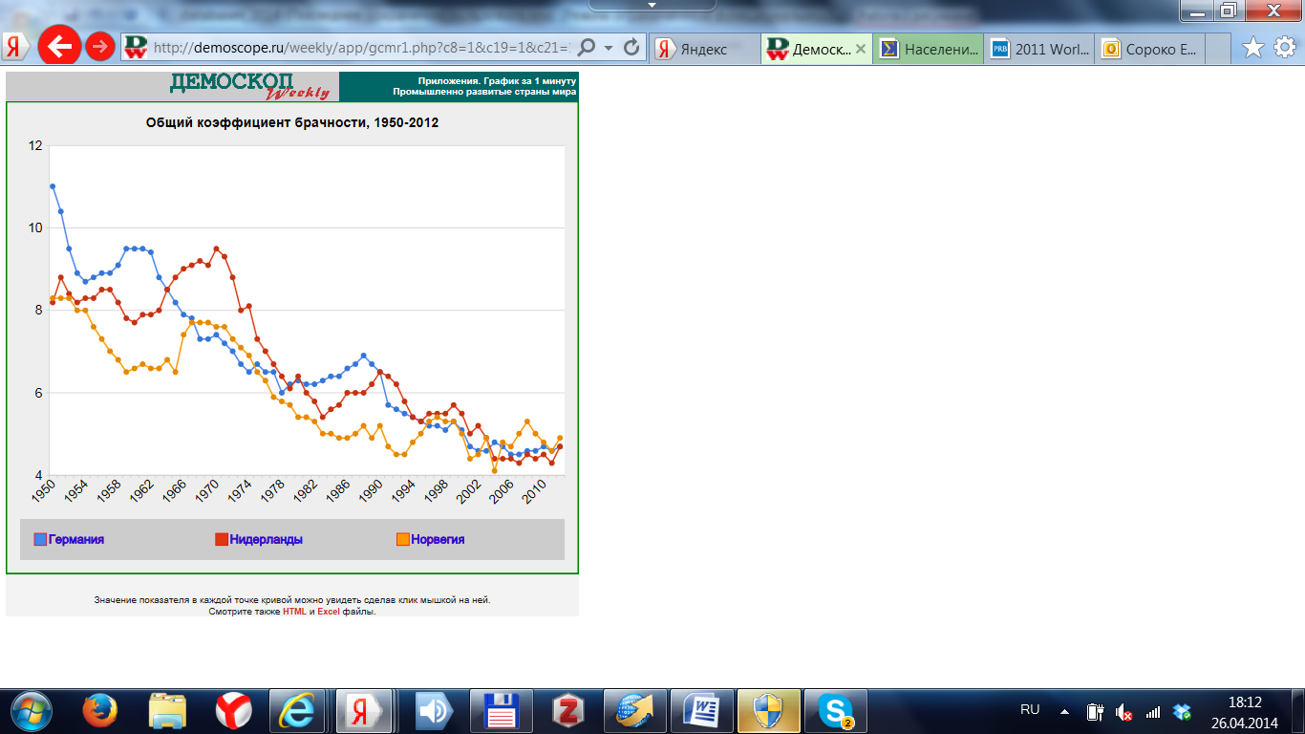
(obtained using the Demoscope Weekly feature “Graph in 1 minute” http://demoscope.ru/weekly/app/graphcmr1.php).
Can we judge about the values of this indicator in Sweden in the same period basing on the values in three countries mentioned? Find these CMR values using demographic databases. Analyze dynamics in Sweden in comparison with other countries. What is common and what is different for these countries? Can we speculate on what are the reasons of difference and distinguishing features of Sweden?
Task 3. Human Mortality Database http://www.mortality.org/ is one of the most valuable databases on mortality. You need to rank 20 selected countries available in HMD for males and females by life expectancy at 15 in 2010. How many files must be processed? What are the main steps of data processing?

