Job Announcement Brass Blacker Chair in Demography

Please find attached a Job Announcement at the London School of hygiene & tropical medicine, faculty of epidemiology & population Health.
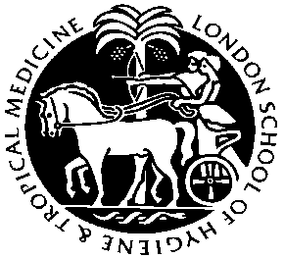
LONDON SCHOOL OF HYGIENE &
TROPICAL MEDICINE

FACULTY OF EPIDEMIOLOGY & POPULATION HEALTH

BRASS BLACKER CHAIR/READERSHIP IN DEMOGRAPHY AND HEALTH

The Department of Population Studies (formerly known as the Centre for Population Studies) is seeking a Professor/ Reader in the area of demography and health. This is a prestigious post and the expected appointee would have an established reputation and research interests in areas related to demography and health. Such areas of research expertise and interest might include population dynamics and development; interactions between population, climate change and the environment; fertility and family planning; the measurement and explanation of mortality trends; or the demographic dimensions of inequality

The successful candidate will hold a without-duration contract and be appointed at the level of professor or reader according to qualifications and experience.

Applications should be made on-line via our website at http://jobs.lshtm.ac.uk
The reference for this post is BBDH. Applications should also include a CV and the names and email contacts of 3 referees who can be contacted immediately if shortlisted. Closing date for applications is 17 September 2010. Any queries regarding the application process may be addressed to jobs@lshtm.ac.uk Please quote reference BBDH.

The London School of Hygiene & Tropical Medicine is committed to being an equal opportunities employer.

