If this letter is hard to read and the pictures are missing please go here for the intended look
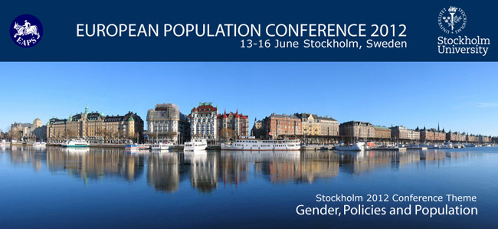

Call for Abstracts

European Population Conference 2012
The European Association for Population Studies invites contributions to the European Population Conference. The EPC 2012 will be hosted at Stockholm University in Stockholm, 13-16 June 2012.
Simultaneous sessions are the core of the conference program. The deadline for the submission of an Abstract is October 15, 2011. Abstracts can only be submitted at the Conference website http://epc2012.princeton.edu. Submissions should be made to one of the conference topics which will be developed into a series of sessions by the Convener.
Topics and Conveners
- Fertility |  | Anna Matysiak
- Families and households |  | Albert Esteve
- Sexual and reproductive health |  | Ester Rizzi
- Internal migration, regional and urban issues |  | Leo van Wissen
- Health, morbidity and mortality |  | Vladimir Canudas-Romo
- International migration and migrant populations |  | Kirk Scott
- Ageing and intergenerational relationships |  | Karen Glaser
- History |  | Anders Brändström
- Data and methods |  | Jutta Gampe
- Human capital and well being |  | Vegard Skirbekk
- Economics and labour market issues |  | Chiara Pronzato
- Life course |  | Ann-Zofie Duvander
- Policy issues |  | Olivier Thevenon
- Development and environment |  | Jane Falkingham
At the EPC 2012 only one submission as a first author is allowed; participants may however co-author other papers/presentations. Submissions may take the form of an abstract although full papers are preferred. Authors will be informed about acceptance of their paper by mid- January 2012.
For more information visit the website: http://epc2012.princeton.edu

