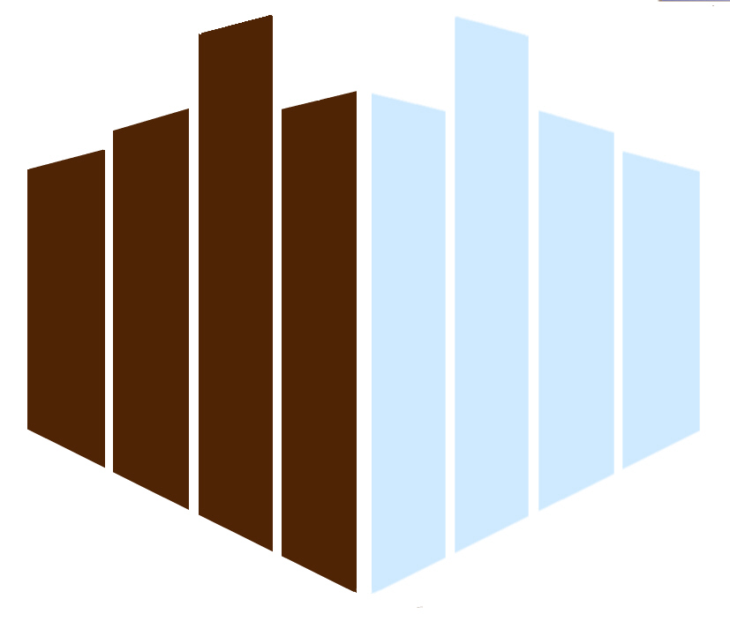
SCORUS
Standing Committee On
Reginal and Urban Statistics

Invitation
to the 2008
Berlin SCORUS Meeting

SCORUS, the Standing Committee On Regional and Urban Statistics, is part of IAOS, the International Association of Official Statisticians in ISI, the International Statistical Institute. The annual Berlin SCORUS meetings are for scientists from universities and research institutes, statisticians, selected experts from welfare and public health institutions, from firms and unions, social workers and others. They are organized by Prof. Dr. Eckart Elsner for to speak about regional and urban issues concerning young people. New results about the situation of children and youngsters are presented in an international atmosphere to stimulate comparable investigations and actions in other places in order to give some help to persons in charge of young people.
The 2008 meeting will be the 13th in a series with the title
“Statistics and the Help for Young People in Big Cities”.
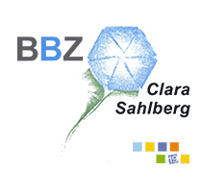
The time of the 2008 meeting will be again quite near to Easter, from Monday to Wednesday

17 - 19 March 2008,
in the South-West of Berlin, in
Bildungs- und Begegnungszentrum “Clara Sahlberg”
Koblankstraße 10
14109 Berlin-Wannsee
The BBZ is situated in the Berlin-Potsdam Cultural Landscape protected by UNESCO. The focus of our Berlin SCORUS meetings is changing from year to year. In 2007 we decided, that in 2008 it will be
“Demographic Ageing”.

About the venue
BBZ is an institution of Vereinigte Diensleistungsgewerkschaft (ver.di), the United Services Union in the German Unions Association. The abbreviation BBZ means in English translation Educational and Meeting Centre “Clara Sahlberg”. Clara Sahlberg (1890 – 1977) was a unionist, fighting for the improvement of the situation of workers, female workers especially.
We are always looking for the best conditions and after negotiations we could get even better prices in the venue than last year. The accommodation will cost you for one night in one of the 70 single rooms only 45,- € a night, in a double bed room you will have to pay 30,- € per person and night. Each of the seminar participants will be charged with 8,50 € per day for using the meeting rooms, beamer, lap tops, micro, technical assistance and services. Water and juices in the seminar room are included in this fee. Accompanying persons not taking part in the seminar do not have to pay this fee. It would be a little bit inconvenient for you, but you also can stay in any hotel of Berlin.
Prices for breakfast, drinks and cakes during the health breaks, lunch, supper and the ceremonial supper on Wednesday you will find on the registration form.
The meeting will start on Monday morning. It again will be possible to combine the meeting with an Easter Holiday in Berlin or Potsdam. If there is no arrangement for such a longer stay, you should leave BBZ on Thursday in the morning (after the farewell evening).

How to get there?
The venue is situated at the water front in the Berlin-Potsdam Cultural Landscape (1660 - 1862).
Berlin Public Transport (BVG) tickets allows you to travel by bus, by tram, by metropolitan trains (S-Bahn), by metro (U-Bahn) or by BVG-ships. Within two hours you can change the means without buying a new ticket, but you have to travel in the same direction. To reach the conference venue, you need an A/B ticket (2,10 €).
If you arrive by train at Hauptbahnhof, take either Regional Express R7 (18 min) or take S-Bahn S7 (26 min) direction to Potsdam, get out at Wannsee station (S-Bahnhof Wannsee) If you arrive at Tegel Airport first take a bus (direction “Zoologischer Garten”), either the quick bus X9 (get out at “Westkreuz”) or bus 109 (get out at “Bahnhof Charlottenburg”) and take S-Bahn S7 as above. cross the street, enter bus 114 (destination “Krankenhaus Heckeshorn”); the conference venue is at the fourth stop “Koblanckstraße” (3 min).
A taxi lift from Wannsee station will cost about 7,00 Euros.
If you come by car, please leave A115 (E51) at Steglitz-Zehlendorf, take Potsdamer Chaussee and Königstraße (B1). After the bridge in Wannsee take the first street to the right (“Am großen Wannsee”) and continue to Koblanckstraße.

The scientific program
Please tell the preliminary title of your talk just now. If you need more than 20 minutes please tell it too. To make it more interesting for an international audience, you could compare the situation in your region with the situation elsewhere. If you want to compare with Germany, the search for data can be done in English under http://www.statistik-portal.de/en/, you can also write to info@destatis.de, maps exist under http://www.destatis.de/atlas/atlas.svgz, Berlin data are available under http://www.statistik-berlin.de or together with Berlins surrounding area of Brandenburg under http://www.statistik-berlin-brandenburg.de (via e-mail write to info@statistik-bbb.de). The program will be provided after all of you have conveyed the title of their lecture. On the Internet you may have a look at http://www.scorusnet.com too.

The social program
On Monday in the afternoon we will have the probably cheapest excursion by ship you ever had, because this excursion costs you two tickets for public transport, which you would have needed anyhow. Together we will be about 25 min on the boat from Wannsee to Kladow and 25 min back. In Kladow we will be walking to the place, where the mother of Bismarck was living in former times. After the meal in the evening for about 20 min we will have a free little concert for the group of our participants in the venue given by a Japanese professional pianist.
On Tuesday after our lectures we will go to see the Berliner Dom, where we will have a guided tour. This place is not far from that we saw last year (GDR Palast der Republik). The Berliner Dom is the biggest place of worship in the capital, and the Kaiser wanted it to be a centre of the Protestants in Germany. This building had been destroyed during the Second World War. In 1975 (GDR times) the reconstruction started with financial support of the government of the Federal Republic and the Protestant Church of Germany. In June 2002 the last dome-mosaic had been revealed solemnly, only the cross of 14 m height on top is still under reconstruction. Year by year thousands of visitors from all countries want to see this place. All have to pay a cathedral conservation fee of 5.- or 3,- €. After the tour we can walk to Berlins biggest shopping mall Alexa, which had been opened in summer 2007 and there we can sit to have a snack or ice cream.
On Wednesday, we will go in the afternoon to Villa Liebermann (impressionist painter, summer house near BBZ) and after this we will have our Farewell Dinner in the evening.

Questions
Questions concerning accommodation, food and local facilities of the venue please ask the team of
Bildungs- und Begegnungszentrum
tel. +49 30 806 713 0
fax +49 30 806 713 560
and concerning the program and the organisation you can ask
Prof. Dr. Eckart Elsner
tel.: +49-30-365 37 82
fax: +49-30-368 099 66
e-mail: Profelsner@aol.com.
.

Berlin, November 2007

In this case you will have to tell this in advance (contact coordinates are given at the end).
BVG: Berliner Verkehrsgesellschaft
S-Bahn is a quick city train, U-Bahn is a subway or underground.
e.g. the ferry boat between Berlin-Kladow and Berlin-Wannsee
Make sure, that you can take part in it.

